**Splash Screen**

**Objective:** We’re going to add a splash screen with music that will lead us into our game.

1. Create a **new scene**
2. Remove the **directional light**
3. Add your chosen skybox to the skybox in this scene
4. Point the **camera** towards something in your skybox and adjust your **Field** **of** **View** to get a good loading screen view.

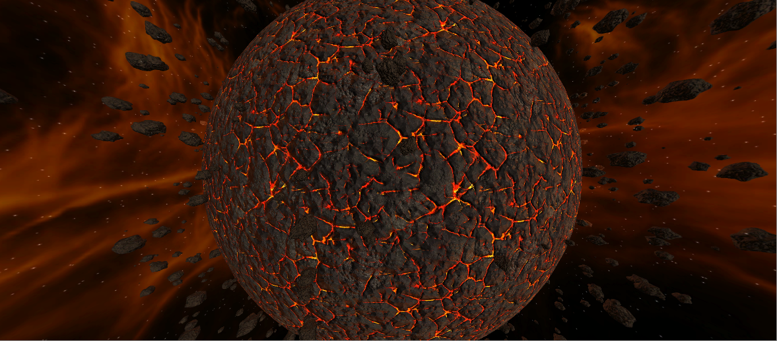

1. Save Scene as Splash
2. Create an **Empty** **Game** **Object** and name it **Music Player** and don’t forget to Reset its position.
3. Add an **Audio** **Source** component to it.
4. Go find a song that you like for an intro and add it to the Audio Source.

**Challenge**: Get the next level to load. Don’t worry if the song cuts off.